10 pF 100 | 20 pF 200 | 47 pF 470 | 100 pF 101
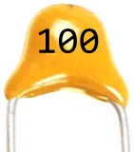  Multilayer  Monolitic  Ceramic  Capacitor | 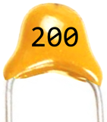  Multilayer  Monolitic  Ceramic  Capacitor | 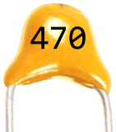  Multilayer  Monolitic  Ceramic  Capacitor | 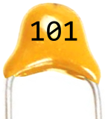  Multilayer  Monolitic  Ceramic  Capacitor
Capacitance Tolerance = ±10%  Lead Spacing = 5.08 mm  Voltage Rating = 50 V  10 pf = 0.01 nf = 0.00001 µf | Capacitance Tolerance = ±10%  Lead Spacing = 5.08 mm  Voltage Rating = 50 V  20 pf = 0.02 nf = 0.00002 µf | Capacitance Tolerance = ±10%  Lead Spacing = 5.08 mm  Voltage Rating = 50 V  47 pf = 0.047 nf = 0.000047 µf | Capacitance Tolerance = ±10%  Lead Spacing = 5.08 mm  Voltage Rating = 50 V  100 pf = 0.1 nf = 0.0001 µf
150 pF 151 | 220 pF 221 | 330 pF 331 | 470 pF 471
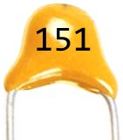  Multilayer  Monolitic  Ceramic  Capacitor | 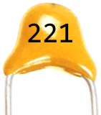  Multilayer  Monolitic  Ceramic  Capacitor | 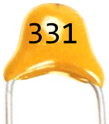  Multilayer  Monolitic  Ceramic  Capacitor | 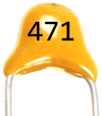  Multilayer  Monolitic  Ceramic  Capacitor
Capacitance Tolerance = ±10%  Lead Spacing = 5.08 mm  Voltage Rating = 50 V  150 pf = 0.15 nf = 0.00015 µf | Capacitance Tolerance = ±10%  Lead Spacing = 5.08 mm  Voltage Rating = 50 V  220 pf = 0.22 nf = 0.00022 µf | Capacitance Tolerance = ±10%  Lead Spacing = 5.08 mm  Voltage Rating = 50 V  330 pf = 0.33 nf = 0.00033 µf | Capacitance Tolerance = ±10%  Lead Spacing = 5.08 mm  Voltage Rating = 50 V  470 pf = 0.47 nf = 0.00047 µf
680 pF 681 | 1 nF 102 | 2.2 nF 222 | 3.3 nF 332
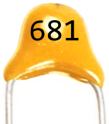  Multilayer  Monolitic  Ceramic  Capacitor | 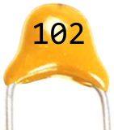  Multilayer  Monolitic  Ceramic  Capacitor | 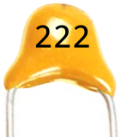  Multilayer  Monolitic  Ceramic  Capacitor | 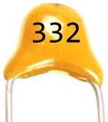  Multilayer  Monolitic  Ceramic  Capacitor
Capacitance Tolerance = ±10%  Lead Spacing = 5.08 mm  Voltage Rating = 50 V  680 pf = 0.68 nf = 0.00068 µf | Capacitance Tolerance = ±10%  Lead Spacing = 5.08 mm  Voltage Rating = 50 V  1 nf = 1,000 pf = 0.001 µf | Capacitance Tolerance = ±10%  Lead Spacing = 5.08 mm  Voltage Rating = 50 V  2.2 nf = 2,200 pf = 0.0022 µf | Capacitance Tolerance = ±10%  Lead Spacing = 5.08 mm  Voltage Rating = 50 V  3.3 nf = 3,300 pf = 0.0033 µf
4.7 nF 472 | 6.8 nF 682 | 10 nF 103 | 22 nF 223
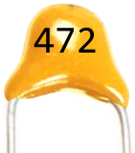  Multilayer  Monolitic  Ceramic  Capacitor | 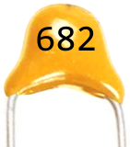  Multilayer  Monolitic  Ceramic  Capacitor | 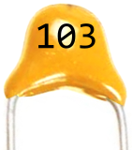  Multilayer  Monolitic  Ceramic  Capacitor | 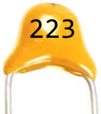  Multilayer  Monolitic  Ceramic  Capacitor
Capacitance Tolerance = ±10%  Lead Spacing = 5.08 mm  Voltage Rating = 50 V  4.7 nf = 4,700 pf = 0.0047 µf | Capacitance Tolerance = ±10%  Lead Spacing = 5.08 mm  Voltage Rating = 50 V  6.8 nf = 6,800 pf = 0.0068 µf | Capacitance Tolerance = ±10%  Lead Spacing = 5.08 mm  Voltage Rating = 50 V  10 nf = 10,000 pf = 0.01 µf | Capacitance Tolerance = ±10%  Lead Spacing = 5.08 mm  Voltage Rating = 50 V  22 nf = 22,000 pf = 0.022 µf
33 nF 333 | 47 nF 473 | 68 nF 683 | 100 nF 104
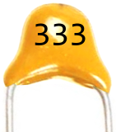  Multilayer  Monolitic  Ceramic  Capacitor | 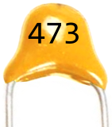  Multilayer  Monolitic  Ceramic  Capacitor | 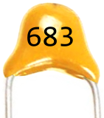  Multilayer  Monolitic  Ceramic  Capacitor | 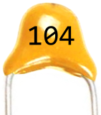  Multilayer  Monolitic  Ceramic  Capacitor
Capacitance Tolerance = ±10%  Lead Spacing = 5.08 mm  Voltage Rating = 50 V  33 nf = 33,000 pf = 0.033 µf | Capacitance Tolerance = ±10%  Lead Spacing = 5.08 mm  Voltage Rating = 50 V  47 nf = 47,000 pf = 0.047 µf | Capacitance Tolerance = ±10%  Lead Spacing = 5.08 mm  Voltage Rating = 50 V  68 nf = 68,000 pf = 0.068 µf | Capacitance Tolerance = ±10%  Lead Spacing = 5.08 mm  Voltage Rating = 50 V  100 nf = 100,000 pf = 0.1 µf

220 nF 224 | 470 nF 474 | 1 µF 105 | 10 µF 105
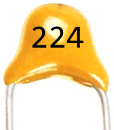  Multilayer  Monolitic  Ceramic  Capacitor | 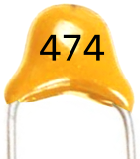  Multilayer  Monolitic  Ceramic  Capacitor | 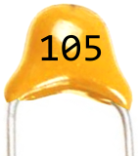  Multilayer  Monolitic  Ceramic  Capacitor | 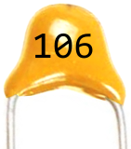  Multilayer  Monolitic  Ceramic  Capacitor
Capacitance Tolerance = ±10%  Lead Spacing = 5.08 mm  Voltage Rating = 50 V  220 nf = 220,000 pf = 0.22 µf | Capacitance Tolerance = ±10%  Lead Spacing = 5.08 mm  Voltage Rating = 50 V  470 nf = 470,000 pf = 0.47 µf | Capacitance Tolerance = ±10%  Lead Spacing = 5.08 mm  Voltage Rating = 50 V  1 µf = 1,000 nf = 1,000,000 pf | Capacitance Tolerance = ±10%  Lead Spacing = 5.08 mm  Voltage Rating = 50 V  10 µf = 10,000 nf = 10,000,000 pf

